DM Class:

Binary classification has k in odd number for the k nearest to break the ties in case of any.

Euclinian matrix: To calculate the hypothesis / distance between two points.

Cosine similarity

Text classification : each text or a letter contains its own ID.

In the unsupervised dataset, all we could do is to find the data or to create a cluster from the similar data since we do not have a D.V in this case.

K-Means Clustering

DM Models:

1. Supervised

a. Classification (Discrete D.V)

- Decision Tree (Highly Explainable) // (High Performance)

- Random forest (Medium Explainable)

- Logistic Regression (Not so highly Explainable)

- Naive Beyaes (Highly Explainable) // (High Performance)

- Neural Networks/ Multi Layered Perceptron (Low Explainability) // (High Performance)

- KNN (Highly Explainable) // (Low Performance)

b. Regression (Continuous D.V)

- Linear Regression (Highly Explainable)

2. Un-Supervised

a. Clustering

- K-means Clustering

b. Association Rule Mining

-Aprion

Random forest has more accuracy than the decision tree model.

Cost function:

Model for univariate linear regression.

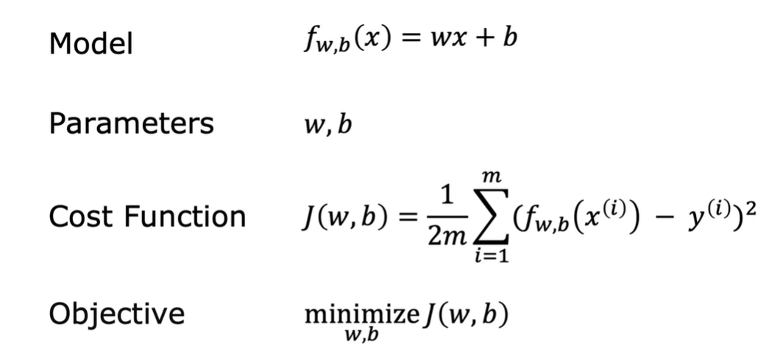

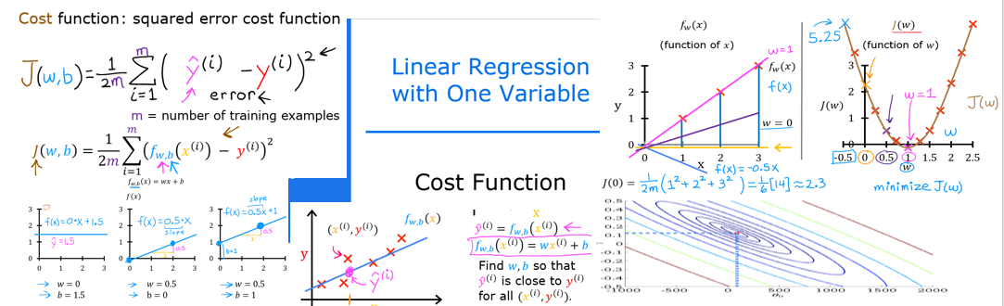

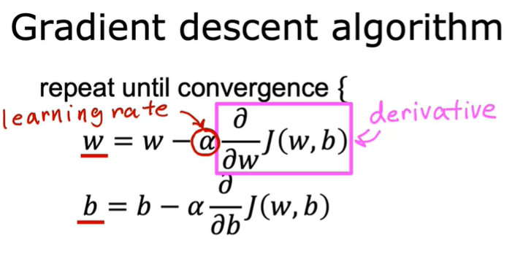

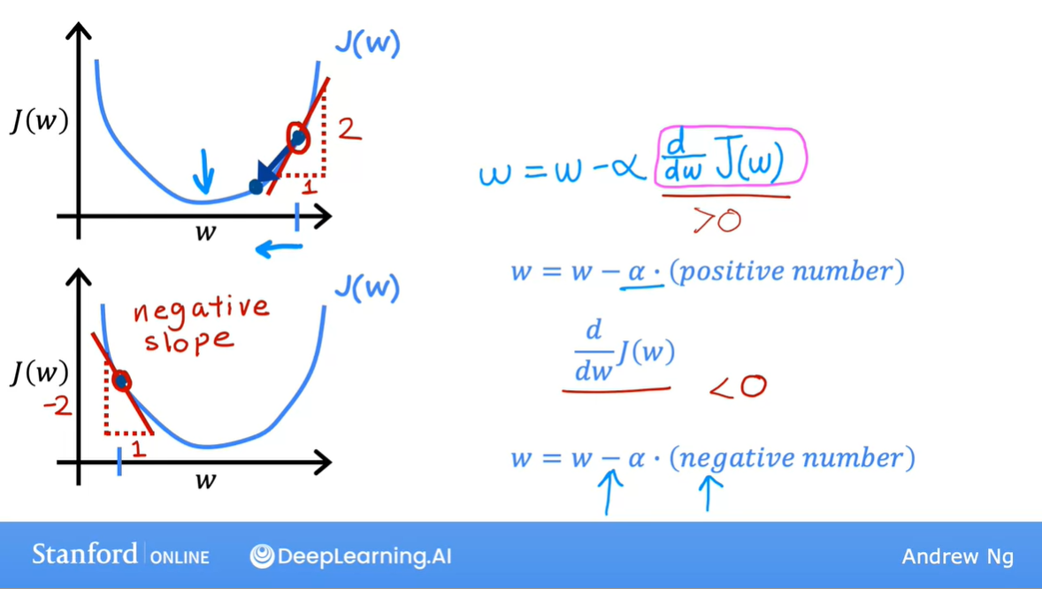

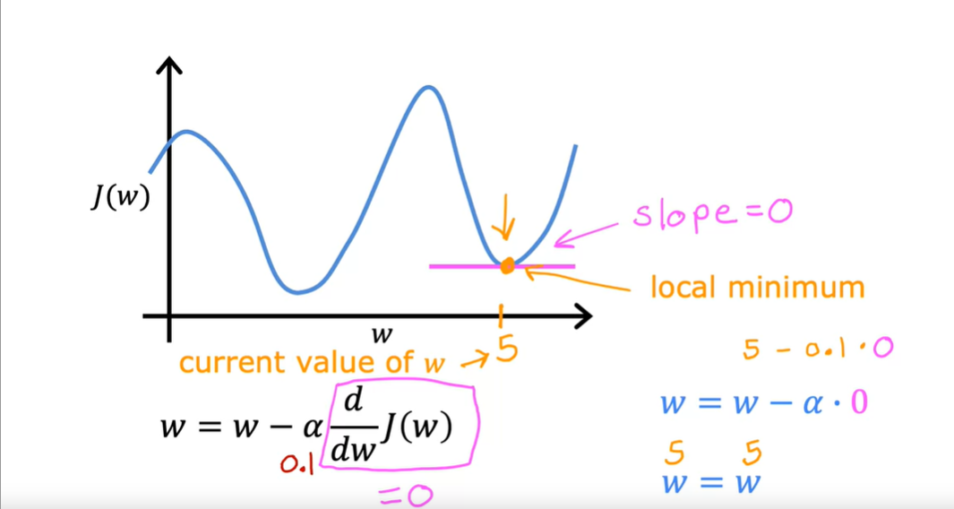

It might take larger steps initially but the gradient decent will take smaller steps as it reaches closer to zero.

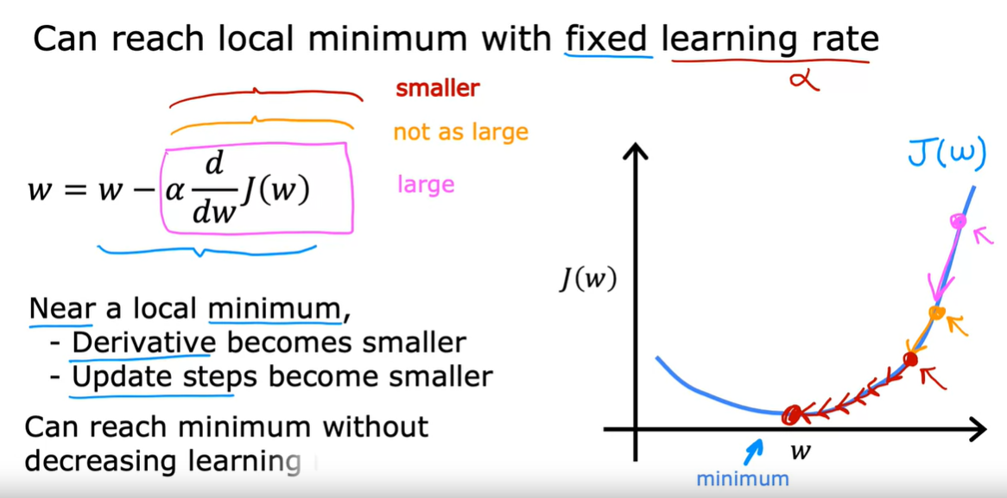

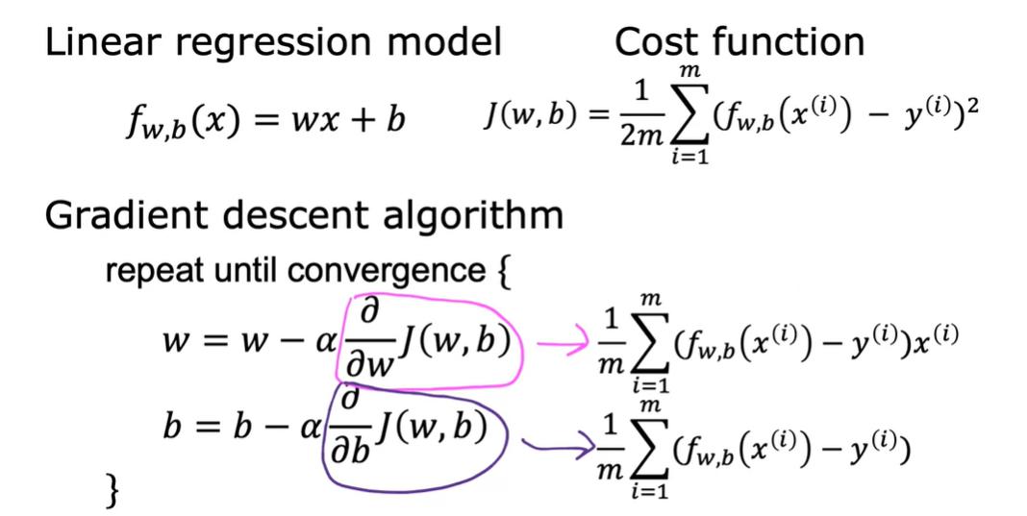

So here the b doesn’t have no x(i) and hence we consider only \*2 and not \*2x(i)

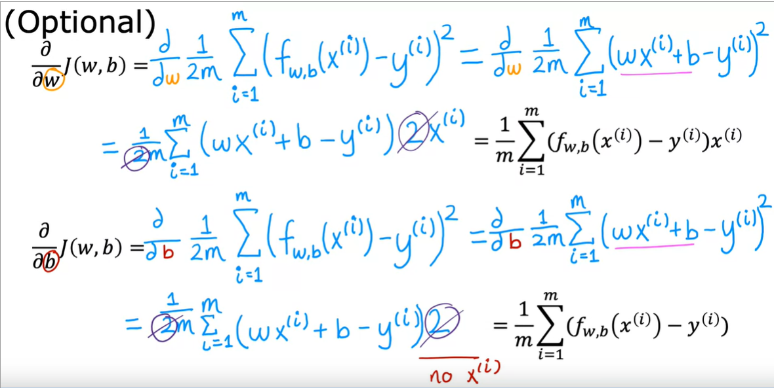

When there are more than a single feature in the dataset then we are going to use the below procedure. This is the formula for Multiple Linear Regression.

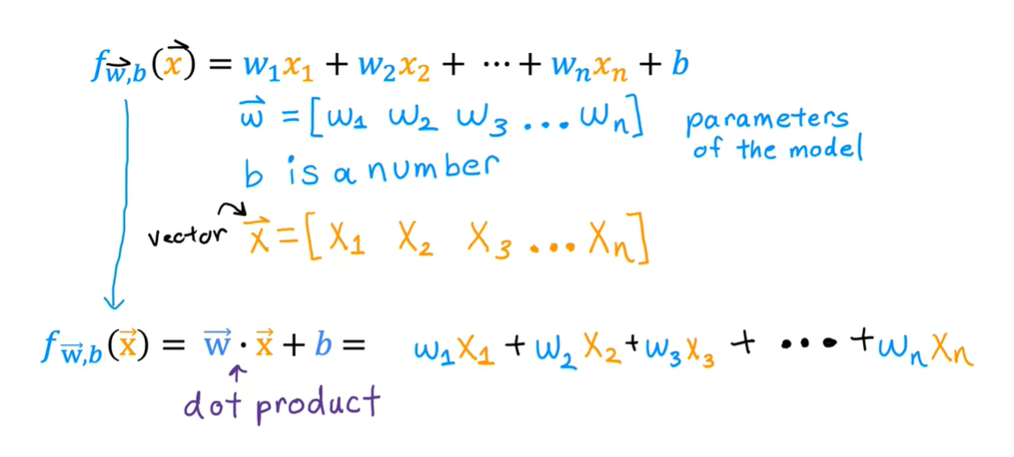

How to use vectorization in a code?

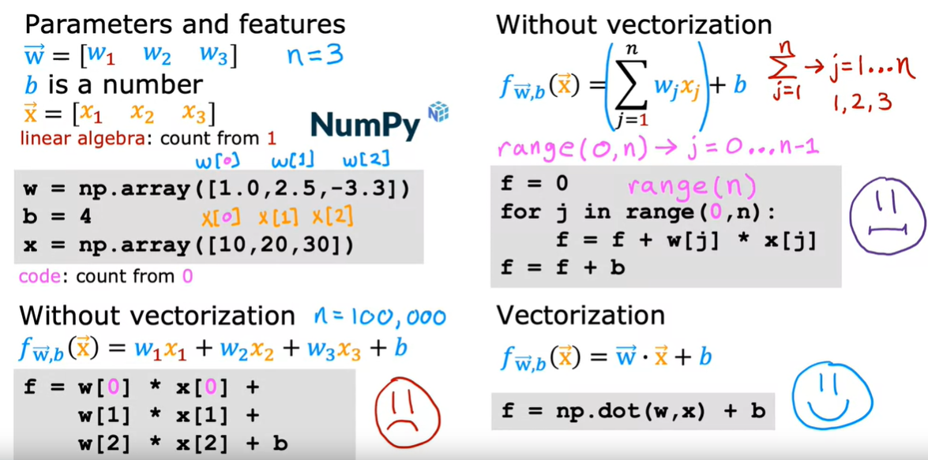

You can just use np.dot function which denotes the dot product of w, x (w0x0+w1x1+w2x2+----+wnxn).

How does this vectorization work in a computer opposed to the traditional non-vectorization code?

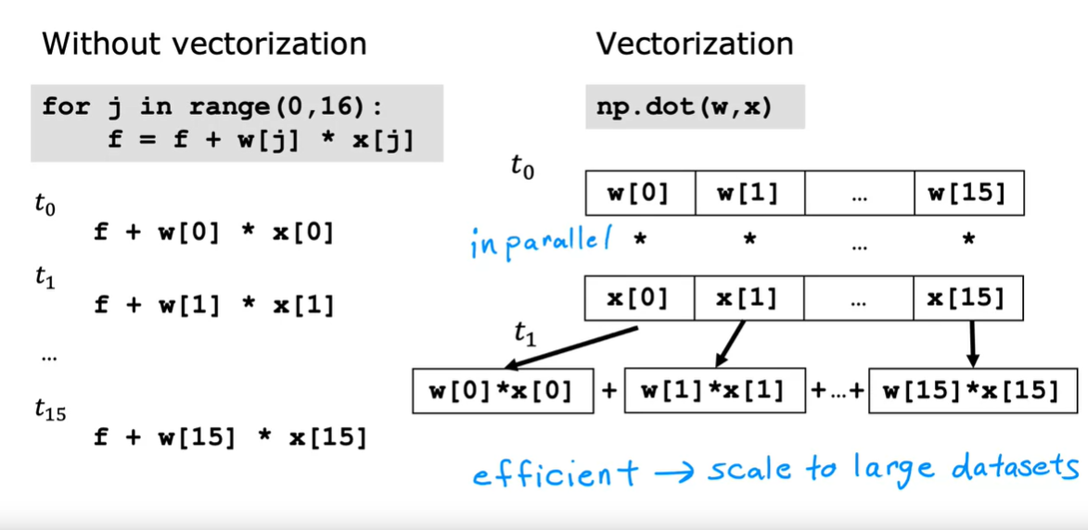

How does vectorization work in the case of the Gradient descent multiple linear regression scenario?  
